CS 499
Abdel Ouedraogo
January 31, 2026
Milestone Three Narrative: Algorithms and Data Structure
- Brief Description of the Artifact
This artifact is an Android application developed as the final project for the CS360 course. It was created on June 22, 2025. The application allows users to track their weight over time. The app provides functionality for user login, account creation, and guest access. Once logged in, users can enter their weight, which is permanently stored in a local database. Users also have the option to delete entries if desired. Because the data is stored persistently, the application enables users to track their progress over time.
- Justification for Including the Artifact in My ePortfolio
I selected this artifact because it demonstrates my ability to apply software engineering concepts to build a functional application that integrates algorithms, data structures, and databases. Specific components that showcase my skills in algorithms and data structures include migrating the application from Java to Kotlin, transitioning from Java’s implicitly mutable collection types to Kotlin’s read-only List interfaces, and separating data storage from presentation logic by exposing data as immutable lists while managing it internally using ArrayList-backed MutableLists. This approach improves data safety, efficiency, and maintainability.
Additionally, I strengthened the application’s type system by enforcing clearer distinctions between user-related data models, reducing the risk of logical errors and improving overall code reliability.
List interface:
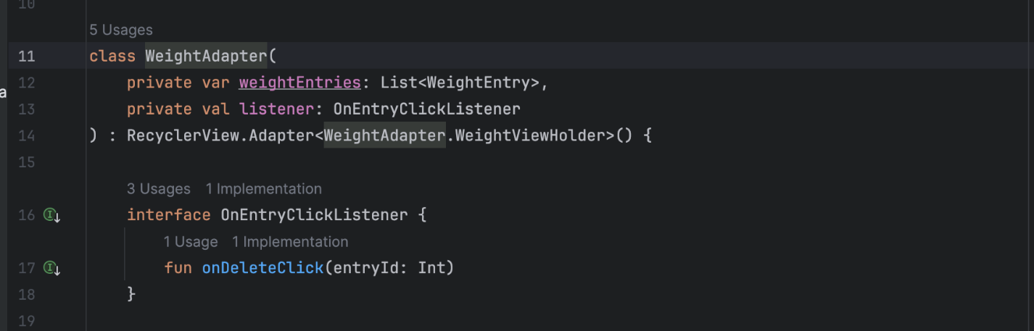
Use of List and ArrayList:
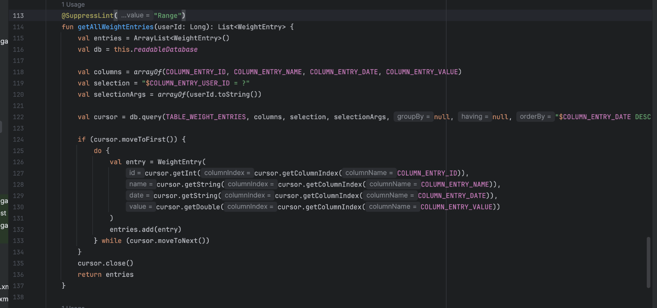
- Course Outcomes and Progress
I believe I have met the course outcomes planned for this artifact enhancement. The application has been fully migrated from Java to Kotlin, addressing algorithmic design, data structure selection, and database integration.
While the migration is functionally complete, further testing and refinement are ongoing. I continue to address IDE warnings and minor issues to improve code quality, performance, and maintainability.
- Reflection on the Enhancement Process
Through enhancing this artifact, I learned that while I am familiar with Kotlin, continued practice is necessary to use the language effectively and idiomatically. One of the primary challenges involved updating Gradle configurations and managing Kotlin dependencies to ensure the enhanced project built and ran correctly.
Another challenge was selecting appropriate data structures. Coming from Java, the distinction between ArrayList, MutableList, and read-only List in Kotlin required careful consideration. Kotlin’s stricter handling of mutability differs from Java and initially caused confusion but ultimately helped reinforce better design practices and clearer separation of responsibilities within the application.

